

Vehicle Management system anlysis & Design

IST 621 Advanced Systems Analysis and Design



**GROUP MEMBERS CSU ID**

* JAGRAVI OJHA
* KRISHNA GANDHI
* LAKSHMI GANESH VAVILAPALLI **2623110**
* MAHARSHI GOWTHAM PEELA **2642094**
* SEBASTIAN KURIAN PARAPURAM
* SHIVAPRASAD KP

1. **SYSTEM ANALYSIS**

**PROJECT MISSION STATEMENT**

1. **Introduction:**

Vehicle Management is a profit center within the Consolidated Industries Corporation that has issues with its vehicle management process and is looking to develop a Vehicle Management system. This system will replace the existing fleet management software used within the corporation that lacks in the transaction process, decision support, marketing etc. Due to these lack of features, the company is facing various problems such as increased workload, losing its business to the competitors and so on.

The objective of Vehicle Management System is to place and track new vehicle request orders, inventory of all vehicles and record who is assigned each vehicle, update vehicle maintenance history and requirements to meet manufacturer warranties, and handle all internal billing.

In addition to this, the Vehicle management system will also support the marketing of vehicles, create accurate data, help in eliminating the workload, prepare summaries of vehicle use, sell vehicles at the best time, process vehicle requests and for preparing a comprehensive history of use and maintenance are done on a given vehicle.

1. **Product Vision and Project Scope:**

* **Product Vision**

Vehicle Management System will have features like simple transaction process, decision support feature for marketing the vehicle, online reservation system and so on, that will decrease the office workload and lower the chance of losing the corporation business to its competitors.

* **Project Scope**

The current project will create a vehicle management software along with an online vehicle reservation system, which is necessary for the vehicle management department to manage the vehicles within a corporation.

1. **Target Markets:**

The target market for the vehicle management software product is for the Consolidated Industries and will be used by the corporation’s Vehicle Management Department to manage its vehicle fleets.

1. **Stakeholders:**

|  |  |
| --- | --- |
| Management | The board of Directors of Consolidated Industries and XYZ Software. |
| XYZ Employees | The six-member team of XYZ Software that are involved in this project are: one Project Manager, one Business Analyst and four Software Designers. |
| Users | The Vehicle Management Department. The category of users is:  **Primary users:** Sally Ryan and Margie Hall.  **Secondary users**: Hank Jeffries, Stan Fox, Jack Sutton, Sue Quinlan, and Helen McGill. |
| Receivers | Customers are both company employees and departments. |

1. **Assumptions and Constraints:**

* **Assumptions**

1. Each customer and vehicle will be identified by a unique identifier.
2. We have not added a “Marketer” stakeholder in the stakeholder list as there is no marketing employee present at the time of the creation of the project.
3. The members of XYZ Software that are performing the project is one Project Manager, one Business Analyst and four Software Designers.
4. Mechanics will provide the next maintenance date and information about the vehicle to the garage supervisor.
5. A feedback device would be given to the customer which would be connected to the VMS server at the time of the check-in.

* **Constraints**

1. Customer and Vehicle records are not properly maintained within the present system which would take more time to collect and store the data in the new system.
2. Vehicle Management Department has a limited budget.
3. Vehicle Management Department were not sure of the solution they are looking for.
4. Vehicle Management Department were not sure about the cause of their problems.
5. Gathering of the data from the Vehicle Management department for the marketing functionality will be difficult as there is no marketer present to provide the information.
6. **Business Requirements:**
7. Vehicle Management System must decrease the workload of the department by at least 40% following its deployment.
8. Vehicle Management System must provide the corporation with at least 20% profit within one year when compared to the previous year.
9. Vehicle Management System must decrease the scheduled maintenance cancellation issues within two months of its deployment.
10. Vehicle Management System must maintain 100% data accuracy.

**REQUIREMENTS**

* **Functional Requirements**

1. VMS must place and track vehicle request orders.
2. VMS should have the feature to support marketing of vehicles.
3. VMS should generate the information necessary for determining the best-selling time of the vehicle.
4. VMS must track where a vehicle is at all times (whether it is with an employee, in the garage or out for repair).
5. VMS must differentiate vehicle user on the basis of department and employee's designation and maintain the respective information.
6. VMS must be able to handle all the complex calculation (for each make and model of vehicle), based on which one can make the decision whether the vehicle must be included in the fleet or not.
7. VMS must handle and generate receipts at the time of check-in and check-out.
8. VMS must aid in providing replacement vehicles for vehicles that are in for scheduled maintenance.
9. VMS must have inventory of all vehicles and should be able to track the customer vehicle’s usage information.
10. VMS must update vehicle maintenance history.
11. Online vehicle reservation system must be incorporated within the VMS.
12. VMS must generate the v
13. Vehicle usage and condition reports by considering factors such as mileage, age etc.,
14. VMS should handle the report queries like pick fields, sort the data and show summaries which are created by the user.
15. VMS should provide a feature to generate customized reports.
16. VMS must maintain the check-in and check-out time for every vehicle.
17. VMS must warn the VM employee about the lack of funds necessary to rent a vehicle.
18. VMS must have an alert system to remind the assignees about the vehicle’s scheduled maintenance.

* **Non Functional Requirements**

1. VMS must maintain accurate data.
2. The system will provide a help and support menu to all interfaces so that the user can interact better with the system.
3. The system should always be available for access except for few days which would be used for maintenance of the system.
4. VMS must make the workflow of the vehicle management department as simple as possible, so as to eliminate the workload.
5. VMS must be user-friendly.

* **Data Requirements**

1. VMS must maintain the resale value data for each make and model and should also maintain the age, mileage, expected maintenance cost data for each vehicle.
2. VMS should maintain the renting department budgets data of each department within the corporation.
3. VMS must provide information about the vehicle’s warranty period.

**USE CASE DIAGRAM**

**Description:** A **use case diagram** at its simplest is a representation of a user's interaction with the system that shows the relationship between the user and the different use cases in which the user is involved. Here we divide use case according to users.

* 1. 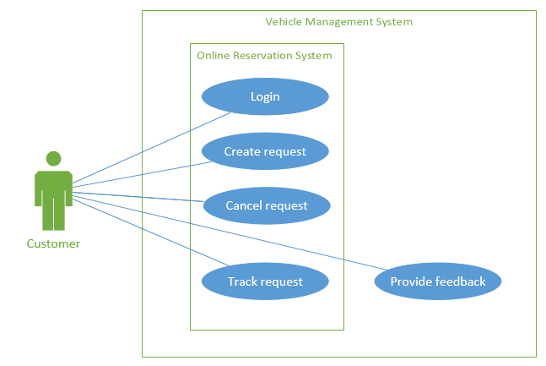**Customer**
  2. 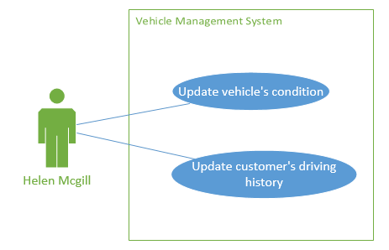**Helen McGill**
  3. **Jack Sutton**

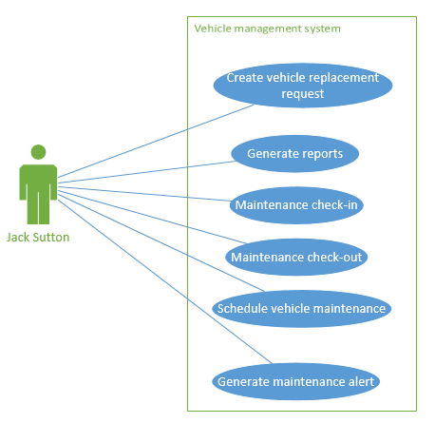

* 1. **Sue Quinlan**

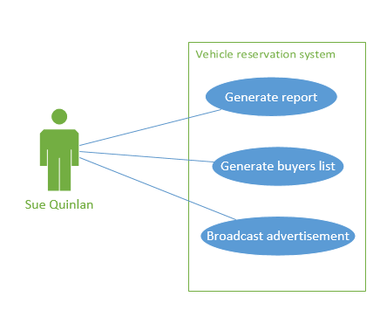

* 1. **Margie Hall**

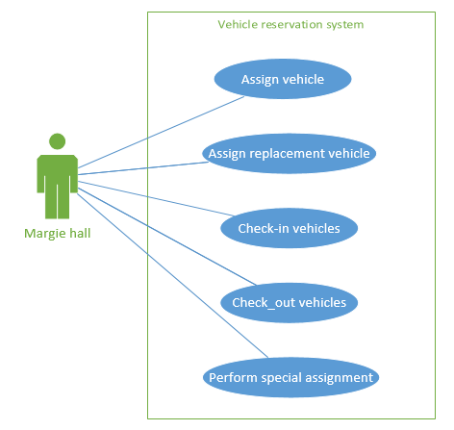

1. 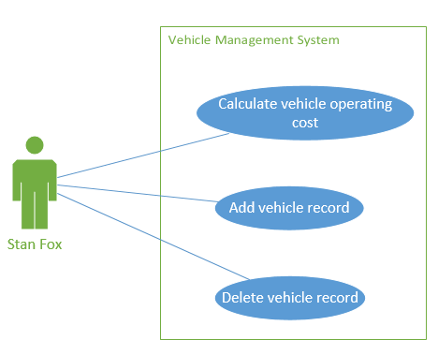**Stan Fox**
2. **Sally Ryan**

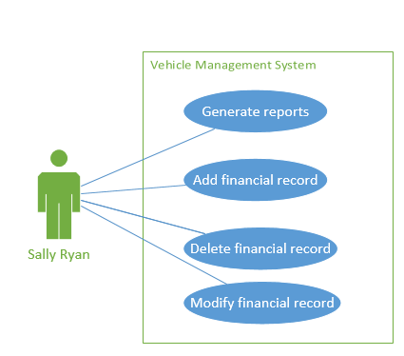

**USE CASE DESCRIPTION**

|  |  |
| --- | --- |
| **Use Case ID** | UID001 |
| **Use Case Name** | Login |
| **Description** | In order to access the online reservation system service, the customers must login in to the system |
| **Primary Actor** | Customer (either an individual employee or a department) |
| **Secondary Actor** | None |
| **Stakeholders &Needs** | **Customer -** Securely log in to the online reservation system  **Vehicle department-** Ensure that the customer is an authorized user |
| **Assumptions** | All the customers have the valid login details |
| **Pre Conditions** | Customer must have authorized privileges to login |
| **Post Conditions** | Customer must be logged in to the online reservation system |
| **Trigger** | Customer initiates this action by clicking the login button |
| **Basic Flow** | 1. Customer enters the online reservation system’s website address in the web browser 2. He enters the username and the password in their respective fields 3. Clicks the login button to enter into their user’s homepage |
| **Extensions** | 1. Customer cancels the transaction: The use case ends 2. Entered login details are invalid or incomplete:    1. System alerts the customer about the entered invalid details    2. Customer re-enters the valid data in their respective data fields and the activity resumes 3. Upon 3 unsuccessful login trials:    1. The system will prompt the message:             “Contact: Margie Hall, Phone No. (xxx)-xxx-xxxx” and   the   use case ends |

**Customer Use Case Descriptions:**

|  |  |
| --- | --- |
| **Use Case ID** | UID002 |
| **Use Case Name** | Create Request |
| **Description** | In order to request a vehicle from the corporation’s rental fleet, the customer must perform the request vehicle function within the online reservation system. |
| **Primary Actor** | Customer (either an individual employee or a department) |
| **Secondary Actor** | None |
| **Stakeholders &Needs** | Customer - Reserve the vehicle on his own(online) instead of contacting the vehicle department. |
| **Assumptions** | The customer that is reserving a vehicle has an approved authorization code. |
| **Pre Conditions** | The customer must be logged onto the online reservation system and must have necessary details to request a vehicle. |
| **Post Conditions** | The vehicle request must be created. |
| **Trigger** | The customer initiates the action by clicking the “Request Vehicle” button within his homepage. |
| **Basic Flow** | 1. The customer clicks the “Request Vehicle” button. 2. The Request Vehicle window will open where the customer will enter the required information needed to request a vehicle. 3. After the input of the necessary information, the user will submit the request. 4. A confirmation page will open, providing the customer with the details of the successful vehicle request. A unique request ID will be created for the customer to enable him to track the vehicle request. 5. The customer logs out of the system. |
| **Extensions** | 1. **Customer cancels the operation:** The use case ends.  2. **Online Reservation system detects invalid or incomplete user data:**     2.1. The online reservation system alerts the customer of the problem.     2.2. Customer corrects the problem and the activity resumes.  3. **Online Reservation system is unable to add the vehicle request to its database:**     3.1. Vehicle Management system records the transaction in the logs, informs Margie Hall of the problem and asks whether the transaction should be held.     3.2. Margie Hall confirms that the transaction should be held.     3.3. Vehicle Management system verifies that it is holding the transaction and the use case ends. |

|  |  |
| --- | --- |
| **Use Case ID** | UID003 |
| **Use Case Name** | Track Request |
| **Description** | In order to know the status of the vehicle request, the customer uses this feature to track the vehicle request status |
| **Primary Actor** | Customer (either individual employee or a department) |
| **Secondary Actor** | None |
| **Stakeholders &**  **Needs** | **Customer -** Track a vehicle request on his own(online) instead of contacting the vehicle department |
| **Assumptions** | The customers will be given a unique request id after the vehicle request has been created. |
| **Pre Conditions** | The customer must be successfully logged into the online reservation system and have the unique request ID to track the vehicle |
| **Post Conditions** | The customer must be able to successfully track the status of the vehicle request |
| **Trigger** | The customer initiates the action by clicking the “Track Request” button. |
| **Basic Flow** | 1. Customer hits the “Track Request” button and a pop up window open asking for the unique Request ID 2. Customer enters the unique Request ID in the respective field and hits enter 3. A pop up window of the most recently updated status (either “Pending”, “Cancelled”, “Declined” or “Assigned”) of that particular vehicle request is displayed |
| **Extensions** | 1. Customer cancels the transaction: The use case ends 2. Customer enters the invalid Request ID:    1. System alerts the customer about the entered invalid details    2. Customer re-enters the valid data in their respective data fields and the activity resumes |

|  |  |
| --- | --- |
| **Use Case ID** | UID004 |
| **Use Case Name** | Provide Feedback |
| **Description** | Customer will access this feature to provide the feedback on the particular vehicle that he has just checked in |
| **Primary Actor** | Customer |
| **Secondary Actor** | Margie Hall (Vehicle Reservation Clerk) |
| **Stakeholders &**  **Needs** | **Customer -** Provide the feedback on the vehicle that he has just checked in  **Margie Hall -** The appropriate vehicle’s feedback from the customer |
| **Assumptions** | The customers will be provided with an iPad by the Margie Hall to collect the feedback immediately after the check-in process |
| **Pre Conditions** | The customer must be present at the time of check-in |
| **Post Conditions** | Customer must be able to successfully submit his feedback and this feedback is to be stored successfully |
| **Trigger** | The customer initiates the action by entering the feedback |
| **Basic Flow** | 1. Margie Hall enters the vehicle’s unique id that the customer has just returned 2. Then she clicks the “Provide Feedback” button on the ipad screen and handovers that device to the customer 3. Customer fills all the fields within that feedback page and can also add comments and clicks submit. |
| **Extensions** | 1. Customer doesn't want to provide the feedback: The use case ends 2. Margie enters the invalid Vehicle ID:    1. System alerts Margie about the entered invalid details    2. Margie re-enters the valid data in their respective data fields and the use case resumes 3. System failed to store the provided feedback:    1. Margie relaunches the provide feedback app and the use case resumes |

**Helen McGill Use Case Description**

|  |  |
| --- | --- |
| **Use Case ID** | UID201 |
| **Use Case Name** | Update Vehicle Condition |
| **Description** | This feature allows the user to update or modify the condition information of vehicle |
| **Primary Actor** | Helen McGill |
| **Secondary Actor** | None |
| **Stakeholders &** **Needs** | **Helen McGill** - Review and update the vehicle’s condition |
| **Assumptions** | Helen McGill is logged into the vehicle management system |
| **Pre Conditions** | Helen must have the vehicle id and vehicle condition information to update into the system |
| **Post Conditions** | The system successfully updates the vehicle condition information |
| **Trigger** | Helen initiates this action by clicking on “update vehicle condition” button |
| **Basic Flow** | 1. Helen clicks the “Update Vehicle Condition” button 2. The Update Vehicle Condition window will open where Helen will enter the vehicle id needed to update the vehicle condition 3. She reviews and updates the information about the vehicle condition 4. She then clicks Submit |
| **Extensions** | 1. Helen cancels the transaction: The use case ends. 2. Entered information is invalid or incomplete:    1. System alerts the administrator about the entered invalid information    2. Helen re-enters the valid data in their respective data fields and the use case resumes |

|  |  |
| --- | --- |
| **Use Case ID** | UID202 |
| **Use Case Name** | Update Customer’s Driving History |
| **Description** | This feature allows the user to update the customer’s driving history |
| **Primary Actor** | Helen McGill |
| **Secondary Actor** | None |
| **Stakeholders &**  **Needs** | Helen McGill - Review and update the customer’s driving history |
| **Assumptions** | Helen McGill is logged into the vehicle management system |
| **Pre Conditions** | Helen McGill must have the customer id and driving history information to update into the system |
| **Post Conditions** | The system successfully updates the customer’s driving history in the database |
| **Trigger** | Helen McGill initiates the action by clicking the “Update customer’s driving history” button |
| **Basic Flow** | 1. The Helen McGill clicks the “Update customer’s driving history” button. 2. The Update customer’s driving history window will open where Helen McGill enters the customer id 3. She reviews and then updates the customer’s driving history and clicks submit. |
| **Extensions** | 1. **Helen McGill** **cancels the operation:** The use case ends.  2. **Online Reservation system detects invalid or incomplete user data:**     2.1. The online reservation system alerts Helen McGill of the problem.     2.2. Helen McGill corrects the error and the use case resumes. |

**Jack Sutton Use Case Descriptions**

|  |  |
| --- | --- |
| **Use Case ID** | UID301 |
| **Use Case Name** | Create vehicle replacement request |
| **Description** | This feature enables the user to create vehicle replacement request for vehicles that have to undergo scheduled maintenance. |
| **Primary Actor** | Jack Sutton |
| **Secondary Actor** | None |
| **Stakeholders &**  **Needs** | Jack Sutton - Make a vehicle replacement request |
| **Assumptions** | User has logged into the vehicle management system |
| **Pre Conditions** | Jack Sutton has the vehicle id of the vehicle which is scheduled for maintenance |
| **Post Conditions** | The vehicle replacement request will be created successfully |
| **Trigger** | Jack Sutton initiates the action by clicking the vehicle replacement request button |
| **Basic Flow** | 1. Jack Sutton clicks the “Vehicle Replacement Request” button 2. The Vehicle Replacement window will open where Jack Sutton will enter the necessary information and clicks Submit 3. He selects all the vehicle ids of the vehicles to be replaced from the generated vehicle ids list and clicks Replacement Request |
| **Extensions** | 1. Jack Sutton cancels the transaction: The use case ends. 2. System failed to record the replacement requests:    1. Jack Sutton re performs the use case 3. No vehicles to be replaced for the selected date:   3.1 Display: “No vehicles has to be replaced for the date ‘mm/dd/yyyy’” and the use case ends |

|  |  |
| --- | --- |
| **Use Case ID** | UID302 |
| **Use Case Name** | Generate Reports |
| **Description** | This feature enables the user to generate customizable reports |
| **Primary Actor** | Jack Sutton |
| **Secondary Actor** | Hank Jeffries |
| **Stakeholders &**  **Needs** | **Jack Sutton -** Generate customizable reports  **Hank Jeffries -** Needs the customized reports for the vehicle management department/customer |
| **Assumptions** | Jack Sutton has access to generate only Vehicle Maintenance Department's reports |
| **Pre Conditions** | Jack Sutton is certain about the information that has to be generated as a report |
| **Post Conditions** | Jack Sutton successfully generates the customizable reports |
| **Trigger** | Jack Sutton initiates the action by clicking the generate report button |
| **Basic Flow** | 1. Jack Sutton clicks the “Generate Reports” button 2. The Vehicle Maintenance Department's Report window will open where Jack Sutton will select the type of report to be generated 3. He selects the date and required fields that are to be a part of the report and then clicks Generate |
| **Extensions** | 1. Jack Sutton cancels the transaction: The use case ends. 2. System fails to generate the report:   2.1 Jack Sutton re performs the use case |

|  |  |
| --- | --- |
| **Use Case ID** | UID303 |
| **Use Case Name** | Schedule vehicle maintenance |
| **Description** | This feature enables the user to schedule the vehicle maintenance |
| **Primary Actor** | Jack Sutton |
| **Secondary Actor** | None |
| **Stakeholders &**  **Needs** | **Jack Sutton -** Schedule vehicle maintenance |
| **Assumptions** | Vehicles that are to be scheduled for maintenance are part of the vehicle management fleet |
| **Pre Conditions** | Helen McGill has provided the schedule maintenance dates of the vehicles to Jack Sutton |
| **Post Conditions** | The next scheduled maintenance date of the vehicles that have undergone maintenance are updated successfully |
| **Trigger** | Jack Sutton initiates the action by clicking the schedule maintenance button |
| **Basic Flow** | 1. Jack Sutton clicks the “schedule maintenance” button 2. The Schedule Maintenance window will open where Jack Sutton will enter the vehicle IDs and next Maintenance Dates and clicks Schedule |
| **Extensions** | 1. Jack Sutton cancels the transaction: The use case ends. 2. System failed to record the schedule maintenance dates:    1. Jack Sutton re performs the use case 3. Entered vehicle ID’s is invalid or incomplete:   3.1 System alerts the Jack Sutton about the entered invalid information  3.2 Jack Sutton re-enters the valid vehicle ID’s and the use case resumes |

|  |  |
| --- | --- |
| **Use Case ID** | UID304 |
| **Use Case Name** | Generate maintenance alert |
| **Description** | This feature will generate vehicle maintenance alerts to the customer |
| **Primary Actor** | Jack Sutton |
| **Secondary Actor** | None |
| **Stakeholders &**  **Needs** | **Jack Sutton -** Vehicles to be returned for maintenance on time |
| **Assumptions** | System will generate maintenance alerts only to customers who has checked out the vehicles that have to undergo maintenance within 14 days |
| **Pre Conditions** | Customer contact information is up to date to receive the alerts |
| **Post Conditions** | Customers who has checked out the vehicles that have to undergo maintenance within 14 days will receive the maintenance alert. |
| **Trigger** | Jack Sutton initiates the action by clicking the Generate maintenance alert button |
| **Basic Flow** | 1. Jack Sutton clicks the “Generate maintenance alert” button 2. The Maintenance Alert window will open where Jack Sutton will enter the additional alert information and clicks generate |
| **Extensions** | 1. Jack Sutton cancels the transaction: The use case ends. 2. System fails to generate the vehicle maintenance alerts:   2.1 System alerts Jack Sutton about the failed maintenance alerts  2.2 Jack Sutton re-performs the use case |

|  |  |
| --- | --- |
| **Use Case ID** | UID305 |
| **Use Case Name** | Maintenance Check-in |
| **Description** | This feature allows the user to check-in the vehicles for maintenance |
| **Primary Actor** | Jack Sutton |
| **Secondary Actor** | None |
| **Stakeholders &**  **Needs** | **Jack Sutton -** Check-in the vehicle for maintenance |
| **Assumptions** | The vehicle scheduled for maintenance is present in the vehicle management garage at the time of check- in for maintenance |
| **Pre Conditions** | The vehicles are scheduled for maintenance |
| **Post Conditions** | The vehicle will be successfully checked-in for maintenance and the vehicle’s status will be updated to “Maintenance” |
| **Trigger** | Jack Sutton initiates the action by clicking the Maintenance Check in button |
| **Basic Flow** | 1. Jack Sutton clicks the “Maintenance Check in” button 2. The Maintenance Check in window will open where Jack Sutton will enter the vehicle ID and clicks Check -IN |
| **Extensions** | 1. Jack Sutton cancels the transaction: The use case ends. 2. System failed to perform the check-in operation:    1. Jack Sutton re performs the use case 3. Entered vehicle ID’s is invalid or incomplete:               3.1 System alerts the Jack Sutton about the entered invalid information              3.2 Jack Sutton re-enters the valid vehicle ID’s and the use case resumes |

|  |  |
| --- | --- |
| **Use Case ID** | UID306 |
| **Use Case Name** | Maintenance Check-out |
| **Description** | This feature allows the user to check-out the vehicles for maintenance |
| **Primary Actor** | Jack Sutton |
| **Secondary Actor** | None |
| **Stakeholders &**  **Needs** | **Jack Sutton** - Check-out the vehicle for maintenance |
| **Assumptions** | The vehicle has undergone complete maintenance |
| **Pre Conditions** | The vehicles have moved out of the vehicle maintenance garage |
| **Post Conditions** | The vehicle will be successfully checked-out from maintenance and the vehicle’s status will be updated to “Available” |
| **Trigger** | Jack Sutton initiates the action by clicking the Maintenance Checkout button |
| **Basic Flow** | 1. Jack Sutton clicks the “Maintenance Checkout” button 2. The Maintenance Checkout window will open where Jack Sutton will enter the vehicle ID and clicks Check-Out |
| **Extensions** | 1. Jack Sutton cancels the transaction: The use case ends. 2. System failed to perform the check-out operation:    1. Jack Sutton re performs the use case 3. Entered vehicle ID’s is invalid or incomplete:               3.1 System alerts the Jack Sutton about the entered invalid information   * 1. Jack Sutton re-enters the valid vehicle ID’s and the use case resumes |

**Margie Hall Use Case Descriptions**

|  |  |
| --- | --- |
| **Use Case ID** | UID501 |
| **Use Case Name** | Assign Vehicle |
| **Description** | This feature allows the user to assign the vehicle to the customer |
| **Primary Actor** | Margie Hall |
| **Secondary Actor** | None |
| **Stakeholders &** **Needs** | **Margie Hall -** Successfully assign a vehicle  **Customer -** Vehicle to be assigned to his request |
| **Assumptions** | The customer who requested a vehicle has an approved authorization code. |
| **Pre Conditions** | All the fields in a vehicle request form of a customer are accurately filled |
| **Post Conditions** | The vehicle request must be created and the vehicle status, customer vehicle request will be updated to ‘Assigned’ |
| **Trigger** | Margie Hall initiates this use case by clicking the “Rental Request list” button. |
| **Basic Flow** | 1. Margie Hall clicks the “Rental Request List” button and the system will generate the list of all the vehicle requests with status ‘Pending’ 2. She selects a request from the request list and the assign vehicle window will open 3. She clicks ‘Available vehicles’ button and system will generate all the vehicles that are available for the requested date 4. She selects a vehicle from the available vehicle list and then clicks ‘Assign’ |
| **Extensions** | 1. Margie Hall cancels the operation: The use case ends 2. If Margie Hall detects invalid data in the vehicle request form:    1. She contacts the customer for the valid information and the use case resumes 3. Vehicles for the requested date are unavailable:    1. Margie Hall clicks the “Not Available” button which updates the status of that particular vehicle request form as “Declined” 4. If the customer’s department doesn’t have enough funds or if customer’s rental privileges are revoked:    1. VMS alerts Margie Hall about it and she then updates the Vehicle request status as “Declined”    2. Margie informs the customer about the reason for the declined status of the vehicle request and the use case ends |

|  |  |
| --- | --- |
| **Use Case ID** | UID502 |
| **Use Case Name** | Check-in vehicles |
| **Description** | This feature allows the user to check-in the vehicles |
| **Primary Actor** | Margie Hall |
| **Secondary Actor** | Customer |
| **Stakeholders &**  **Needs** | **Margie Hall -** Check-in the vehicle  **Customer -** receive the bill and provide the vehicle feedback. |
| **Assumptions** | The valid customer is present at the time of check in |
| **Pre Conditions** | The customer information and the vehicle id must match with the details in the system |
| **Post Conditions** | Vehicle’s status will be updated to “Available” and bill will be generated successfully. |
| **Trigger** | Margie Hall initiates this use case by clicking the “Check-In” button. |
| **Basic Flow** | 1. Margie Hall clicks the “Check IN” button 2. The Check in window will open where Margie Hall will enter the customer ID and clicks submit 3. The Checked out vehicles’ ID’s are displayed 4. Margie Hall selects the vehicles’ ID’s to be checked in and clicks Check IN 5. Margie Hall prints the bill and hands it over to the customer |
| **Extensions** | 1.. **Margie Hall cancels the operation:** The use case ends.  2. Margie Hall enters invalid customer ID:  2.1 VMS alerts the Margie Hall about the problem  2.2 Margie Hall reenters valid customer ID and the use case resumes |

|  |  |
| --- | --- |
| **Use Case ID** | UID503 |
| **Use Case Name** | Check-out vehicles |
| **Description** | This feature enables the user to check out vehicles |
| **Primary Actor** | Margie Hall |
| **Secondary Actor** | Customer |
| **Stakeholders &**  **Needs** | **Margie Hall-** Check out the vehicle and the vehicle status to be updated  **Customer -** Get a vehicle and receive receipt |
| **Assumptions** | Valid customer is present at the time of checkout |
| **Pre Conditions** | The vehicle is assigned to the customer ID |
| **Post Conditions** | Vehicle will be checked out and a receipt is generated |
| **Trigger** | Margie Hall initiates this use case by clicking the “Check OUT” button. |
| **Basic Flow** | 1. Margie Hall clicks Check OUT button and the system displays the vehicle check-out page. 2. Margie Hall enters the Customer ID and Clicks submit 3. System generates the list of vehicles assigned associated to the Customer ID that Margie Hall has entered. 4. Margie Hall selects the vehicle to be checked out from the list and clicks Check-Out and system generates the receipt 5. Margie Hall selects Print receipt and hands it over to the customer |
| **Extensions** | 1. **Margie Hall cancels the operation:** The use case ends.  2. Margie Hall enters invalid customer ID:  2.1 VMS alerts the Margie Hall about the problem  2.2 Margie Hall reenters valid customer ID and the use case resumes |

|  |  |
| --- | --- |
| **Use Case ID** | UID504 |
| **Use Case Name** | Perform special assignment |
| **Description** | This feature allows the user to assign vehicles for special cases, where the customer is an Executive or Salesperson, special events and for customer’s request through phone call |
| **Primary Actor** | Margie Hall |
| **Secondary Actor** | None |
| **Stakeholders &** **Needs** | **Margie Hall -** successfully assign a vehicle  **Executive, Salesperson** and **Customer -** to get the vehicle |
| **Assumptions** | They didn’t use the online reservation system to make the vehicle requests |
| **Pre Conditions** | Hank and customer must provide all the necessary information to Margie to perform this operation |
| **Post Conditions** | The appropriate vehicle must be successfully assigned and the vehicle status will be updated to “Assigned” |
| **Trigger** | Margie initiates this action by clicking the “Special Assignment” button. |
| **Basic Flow** | 1. Margie Hall hits the “Special Assignment” button 2. Upon selection of the ‘type of customer’, it populates all the necessary fields to be filled 3. Margie fills all the fields then clicks “Available vehicles” button 4. From the list of all the available vehicles, she chooses the appropriate vehicle for the customer and Clicks ‘Assign’ |
| **Extensions** | 1. Margie cancels the operation: The use case ends 2. System detects invalid user data:    1. VMS alerts the Margie about the problem    2. Margie reenters the valid data and the use case resumes 3. If the customer’s department doesn’t have enough funds or if the customer’s rental privileges are revoked:    1. VMS alerts Margie Hall about it and Margie informs the customer about the reason |

|  |  |
| --- | --- |
| **Use Case ID** | UID505 |
| **Use Case Name** | Assign replacement vehicles |
| **Description** | This feature allows the user to assign vehicles for vehicle replacement request |
| **Primary Actor** | Margie Hall |
| **Secondary Actor** | None |
| **Stakeholders &**  **Needs** | **Margie Hall -** successfully assign a vehicle  **Customer -** to have a vehicle for the entire vehicle assignment period  **Jack Sutton -** to replace the vehicle that requires maintenance |
| **Assumptions** | The vehicle replacement request is created by Jack Sutton |
| **Pre Conditions** | Vehicle replacement requests are created |
| **Post Conditions** | The appropriate vehicle must be successfully assigned to replace the vehicle that has to undergo maintenance and the assigned replacement vehicle status will be updated to “Assigned” |
| **Trigger** | Margie Hall initiates this action by clicking the “Vehicle Replacement List” button. |
| **Basic Flow** | 1. Margie Hall clicks the ‘Vehicle Replacement List’ button and the system will list all the replacement requests 2. She selects a vehicle ID from the replacement request list and the assign vehicle window will open 3. She clicks ‘Available vehicles’ button and system will generate all the vehicles that are available for the requested date 4. She selects appropriate vehicle from the available vehicle list and then clicks ‘Assign’ |
| **Extensions** | 1. Margie Hall cancels the operation: The use case ends 2. System failed to perform the assign replacement vehicle operation:    1. Margie Hall re performs the use case |

**Sally Ryan Use Case Descriptions**

|  |  |
| --- | --- |
| **Use Case ID** | UID101 |
| **Use Case Name** | Generate Reports |
| **Description** | This feature enables the user to generate customized reports |
| **Primary Actor** | Sally Ryan |
| **Secondary Actor** | Hank Jeffries |
| **Stakeholders &**  **Needs** | **Sally Ryan** - Generate customizable financial reports  **Hank Jeffries -** Needs the customized reports for the vehicle management department/customer |
| **Assumptions** | Sally Ryan has access to generate only Vehicle Management Department's financial reports |
| **Pre Conditions** | Sally Ryan is certain about the information that has to be included in the generated report |
| **Post Conditions** | System will successfully generate the customized reports |
| **Trigger** | Sally Ryan initiates the action by clicking the ‘Generate report’ button |
| **Basic Flow** | 1. Sally Ryan clicks the “Generate Reports” button and system opens the Vehicle Management Department's Report window 2. Sally Ryan will select the type of report to be generated i.e., financial report 3. She selects the date and all the required fields that are to be a part of the report and then clicks Generate |
| **Extensions** | 1. Sally Ryan cancels the transaction: The use case ends. 2. System fails to generate the report:    1. Sally Ryan re performs the use case |

|  |  |
| --- | --- |
| **Use Case ID** | UID102 |
| **Use Case Name** | Add financial record |
| **Description** | This feature enables the user to add the financial records in VMS |
| **Primary Actor** | Sally Ryan |
| **Secondary Actor** | None |
| **Stakeholders &**  **Needs** | **Sally Ryan -** Manage and store the financial information of the vehicle department |
| **Assumptions** | The financial record that is to be added is not present within the system |
| **Pre Conditions** | Sally Ryan has all the necessary information of the financial record to be added |
| **Post Conditions** | Financial record is successfully added into the system and a unique financial record ID for the added financial record will be generated |
| **Trigger** | Sally Ryan initiates the action by clicking the ‘Add Financial Record’ button. |
| **Basic Flow** | 1. Sally Ryan clicks on the add financial record button and system will display the New Financial Record window 2. Sally Ryan fills all the necessary fields and clicks ‘Submit’ |
| **Extensions** | 1. Sally Ryan cancels the operation: The use case ends 2. Entered Invalid data:    1. VMS alerts Sally Ryan about the entered invalid data fields    2. Sally Ryan makes the changes and the use case resumes    3. System fails to delete the record:    4. Sally Ryan re performs the use case |

|  |  |
| --- | --- |
| **Use Case ID** | UID103 |
| **Use Case Name** | Delete financial record |
| **Description** | This feature allows the user to delete financial records from VMS |
| **Primary Actor** | Sally Ryan |
| **Secondary Actor** | None |
| **Stakeholders &**  **Needs** | **Sally Ryan -** successfully remove the financial record from VMS |
| **Assumptions** | The financial record that is deleted is not required by the vehicle management department |
| **Pre Conditions** | Sally Ryan has the necessary information of the financial that has to be deleted from VMS |
| **Post Conditions** | The deleted financial record should not exist in VMS |
| **Trigger** | Sally Ryan initiates the condition by clicking on ‘Delete Financial Record’ button. |
| **Basic Flow** | 1. Sally Ryan clicks on the delete financial record button and system will display the Delete Financial Record window 2. Sally Ryan enters the financial record ID and clicks ‘Submit’ 3. The system displays the financial record to be deleted and asks for confirmation 4. Sally Ryan confirms the operation by clicking yes |
| **Extensions** | 1. Sally Ryan cancels the operation: The use case ends. 2. Financial record is already deleted:    1. The system will display the message “financial record does not exist” 3. System fails to delete the record:    1. Sally Ryan re performs the use case |

|  |  |
| --- | --- |
| **Use Case ID** | UID104 |
| **Use Case Name** | Modify financial record |
| **Description** | This feature allows the user to modify financial records in VMS |
| **Primary Actor** | Sally Ryan |
| **Secondary Actor** | None |
| **Stakeholders &**  **Needs** | **Sally Ryan** - modify the financial record in VMS |
| **Assumptions** | Sally Ryan wants to make some modifications to the existing financial record |
| **Pre Conditions** | Sally Ryan has the necessary information of the financial that has to be modified in VMS |
| **Post Conditions** | Financial record is successfully modified |
| **Trigger** | Sally Ryan initiates the condition by clicking on ‘Modify Financial Record’ button. |
| **Basic Flow** | 1. Sally Ryan clicks on the modify financial record button and system will display the Modify Financial Record window 2. Sally Ryan enters the financial record ID and clicks ‘Submit’ 3. The system displays the financial record to be modified 4. Sally Ryan modifies the necessary fields and clicks submit |
| **Extensions** | 1. Sally Ryan cancels the operation: The use case ends.  2. System failed to update the financial record:       2.1 Sally Ryan re performs the use case  3. Entered Invalid data:                  3.1 VMS alerts Sally Ryan about the entered invalid data fields   * 1. Sally Ryan makes the changes and the use case resumes |

**Stan Fox Use Case Descriptions**

|  |  |
| --- | --- |
| **Use Case ID** | UID401 |
| **Use Case Name** | Calculating Vehicle Operating Cost |
| **Description** | This feature enables the user to calculate the vehicle operating cost |
| **Primary Actor** | Stan Fox |
| **Secondary Actor** | None |
| **Stakeholders &** **Needs** | **Stan Fox -** View the vehicle condition and to calculate the vehicle operating cost |
| **Assumptions** | Stan Fox is the authorized user to view the vehicle’s condition and to calculate the vehicle operating cost |
| **Pre Conditions** | The vehicle condition information is up to date and the system is already incorporated with the complex calculation for each make and model of the vehicle to calculate the vehicle operating cost |
| **Post Conditions** | Stan Fox will be able to view the vehicle condition and calculate the operating cost of a vehicle |
| **Trigger** | Stan Fox initiates this use case by clicking the ‘View vehicle condition’ button |
| **Basic Flow** | 1. Stan Fox clicks the ‘View vehicle condition’ button and the view vehicle condition page will be opened 2. Stan Fox enters the Vehicle ID and hits ‘submit’ 3. System generates the vehicle condition information associated to the vehicle ID that the Stan Fox has entered. 4. Stan Fox clicks ‘Calculate vehicle operating cost’ and system will calculate the vehicle’s operating cost based on the vehicle’s make, model and its condition |
| **Extensions** | 1. **Stan Fox cancels the operation:** The use case ends 2. Entered Vehicle ID is invalid:    1. Stan Fox enters the valid Vehicle ID and this use case resumes 3. System failed to calculate the vehicle operating cost or generate vehicle condition information:    1. Margie Hall re performs the use case |

|  |  |
| --- | --- |
| **Use Case ID** | UID402 |
| **Use Case Name** | Add vehicle record |
| **Description** | This feature allows the user to add new vehicle records into the VMS |
| **Primary Actor** | Stan Fox |
| **Secondary Actor** | None |
| **Stakeholders &**  **Needs** | **Stan Fox** - successfully add the vehicle record into the VMS |
| **Assumptions** | The vehicle record that is to be added is not present within the system |
| **Pre Conditions** | Stan Fox has all the necessary information of the vehicle to be added |
| **Post Conditions** | Vehicle record is successfully added into the system, a unique vehicle ID for the added vehicle will be generated and the vehicle’s status is updated to ‘Available’ |
| **Trigger** | Stan Fox initiates the condition by clicking on “Add vehicle” button. |
| **Basic Flow** | 1. Stan Fox clicks on the add vehicle button and system will display the Add vehicle window 2. Stan Fox fills all the necessary fields and clicks ‘Submit’ |
| **Extensions** | 1. **Stan Fox cancels the operation:** The use case ends 2. Entered Invalid data:    1. VMS alerts Stan Fox about the entered invalid data fields    2. Stan Fox makes the changes and the use case resumes |

|  |  |
| --- | --- |
| **Use Case ID** | UI403 |
| **Use Case Name** | Delete vehicle record |
| **Description** | This feature allows the user to delete a vehicle record from VMS |
| **Primary Actor** | Stan Fox |
| **Secondary Actor** | None |
| **Stakeholders &**  **Needs** | **Stan Fox -** successfully delete the vehicle record from VMS |
| **Assumptions** | The vehicle has moved out of the vehicle management fleet. |
| **Pre Conditions** | Stan Fox has the necessary information of the vehicle that has to be deleted from VMS |
| **Post Conditions** | The deleted vehicle record should not exist in VMS |
| **Trigger** | Stan Fox initiates the condition by clicking on “Delete vehicle” button. |
| **Basic Flow** | 1. Stan Fox clicks on the delete vehicle button and system will display the Delete vehicle window 2. Stan Fox enters the vehicle ID and clicks ‘Submit’ 3. The system displays the vehicle record to be deleted and asks for confirmation 4. Stan Fox confirms the operation by clicking yes |
| **Extensions** | 1. Stan Fox cancels the operation: The use case ends.  2. Vehicle record is already deleted:   * 1. The system will display the message “vehicle record does not exist”. |

**Sue Quinlan Use Case Diagram**

|  |  |
| --- | --- |
| **Use Case ID** | UID001 |
| **Use Case Name** | Generate buyers list |
| **Description** | This feature will enable the user to generate the buyers list |
| **Primary Actor** | Sue Quinlan |
| **Secondary Actor** | None |
| **Stakeholders &**  **Needs** | **Sue Quinlan** - Sell vehicles to the corporation’s employees instead of selling it in auction |
| **Assumptions** | The buyers list will contain all the buyers who are inclined to buy the vehicle. |
| **Pre Conditions** | System has the information to analyze and generate the buyers list |
| **Post Conditions** | Sue Quinlan will have potential list of buyers to whom she would be able to sell vehicle. |
| **Trigger** | Sue Quinlan clicks on “Generate buyers list” button. |
| **Basic Flow** | 1. Sue Quinlan clicks the “Generate buyers list” button and system generates the buyers list and displays on the screen. |
| **Extensions** | 1. Sue Quinlan cancels the operation: The use case ends 2. System fails to generate the buyers list:   2.1 Sue Quinlan re performs the use case |

|  |  |
| --- | --- |
| **Use Case ID** | UID002 |
| **Use Case Name** | Broadcast Advertisement |
| **Description** | This feature will allow the user to broadcast the advertisement about the vehicle management department’s rental fleet |
| **Primary Actor** | Sue Quinlan |
| **Secondary Actor** | None |
| **Stakeholders &**  **Needs** | **Sue Quinlan -** Advertise about the vehicle management department’s rental fleet |
| **Assumptions** | System will generate this advertisement to all the corporation’s employees |
| **Pre Conditions** | Sue Quinlan will have all the necessary information to broadcast the advertisement |
| **Post Conditions** | Every customer will receive the broadcast advertising message through emails and text sms |
| **Trigger** | Sue Quinlan clicks on ‘Broadcast advertisement’ button |
| **Basic Flow** | 1. Sue Quinlan clicks on broadcast advertisement button and broadcast advertisement window will be open. 2. Sue Quinlan inputs the advertisement info and clicks broadcast. |
| **Extensions** | 1. **Sue cancels the operation:** The use case ends. 2. System fails to generate the buyers list:   2.1 Sue Quinlan re performs the use case |

|  |  |
| --- | --- |
| **Use Case ID** | UID003 |
| **Use Case Name** | Generate Reports |
| **Description** | This feature enables the user to generate the customizable report |
| **Primary Actor** | Sue Quinlan |
| **Secondary Actor** | Hank Jeffries |
| **Stakeholders &**  **Needs** | **Sue Quinlan** - Feature to generate customized VM’s Rental Department reports as requested by the Hank  **Hank Jeffries** - Receive the VM’s Rental Department reports in a timely manner |
| **Assumptions** | Sue Quinlan has access to generate only VM’s Rental Department reports |
| **Pre Conditions** | Sue Quinlan must be certain about the information that has to be included in the generated report |
| **Post Conditions** | Sue Quinlan must be able to successfully generate the Rental department’s report with the required information |
| **Trigger** | Sue Quinlan initiates this action by clicking the “Generate Report” button on her vehicle management system homepage |
| **Basic Flow** | 1. Sue Quinlan clicks the “Generate Report” button on her VMS homepage and system will open the Vehicle Management Department's Report window 2. Sue Quinlan selects the type of report to be generated i.e., Rental Department’s report 3. She selects the date and all the required fields that are to be part of the report and then clicks ‘Generate’ |
| **Extensions** | 1. Sue Quinlan cancels the transaction: The use case ends 2. System fails to generate the report:    1. Sue Quinlan re performs the use case |

1. **SYSTEM DESIGN**

**CLASS DIAGRAM**

**Description:**

Class diagrams are visual representations of the static structure and composition of a particular system using the conventions set by the Unified Modeling Language (UML).

We developed a class diagram for vehicle management system which include:

1. **customer:** customer class contains all the information about the users requesting for the vehicle.
2. **customerAccount:** customerAccount class contains account related information that is associated with the customer renting the vehicle.
3. **vehRequest:**vehRequest class contains the vehicle request information that are created by the customer via the online reservation system.
4. **vehAssignment:** vehAssignment class containsthe assignment information that has been performed on a vehicle request.
5. **vehReplaceReq:** vehReplaceReq class contains the vehicle replacement request information that is created by the garage supervisor for replacing vehicles that are scheduled for maintenance.
6. **vmsUser:** vmsUser class contains all the information about the employees in the vehicle management department.
7. **vmsUserAccount:** vmsUserAccount class contains account related information that is associated with the employees in the vehicle management department.
8. **vehicle:** vehicle class contains vehicle information of all the vehicles present under the Vehicle Management Department.
9. **vmFinancial:** vmFinancial class contains the financial information of the Vehicle Management department
10. **vehFeedback:** vehFeedback class contains the vehicle feedback information that has been provided by the customers at the time of check-in of the vehicle.
11. **vehMaintenance:** vehMaintenance class contains all the information about the maintenance services performed on a vehicle



**SEQUENCE DIAGRAMS**

**Description**: A Sequence diagram is an interaction diagram that shows how processes operate with one another and in what order.  In our VMS we have six main actors namely Customer, Helen, Jack, Margie, Sally, Stan & Sue. We divided the sequence diagram according to users. Here is the list of sequence diagram related to each user

**Actor: Customer**

1. **Creating the vehicle request**



1. **Cancelling the Vehicle Request**



1. **Tracking the Vehicle’s Request**
2. **Providing Feedback**



**Assumption:** A feedback device would be given to the customer which would be connected to the VMS server

**Actor:** **Margie Hall**

1. **Assigning Vehicles**



**Note:** This sequence diagram depicts how the vehicle is assigned to a customer’s request

1. **Checking out the vehicle**



1. **Checking in the vehicle**



1. **Assigning Replacement Vehicles**



**Note:** Replacement vehicles will be decided based on the type of customer

1. **Performing Special Assignment**

**Assumption:** This feature is only used to assign vehicles for request through phone call and for executives, sales person and for special events



**Actor:** **Jack Sutton**

1. **Generating Maintenance Alerts**



1. **Checking in the vehicle for maintenance**



1. **Checking out the vehicle from maintenance garage**



1. **Generating Reports**

**Assumptions:** Customer can request for the reports only through hank; Hank does not need to be present for receiving reports; Jack can only generate maintenance reports



1. **Scheduling Vehicle for Maintenance**



1. **Creating Vehicle Replacement Request**



**Actor:** **Stan Fox**

1. **Calculating Vehicle Operating Cost**



1. **Adding Vehicle Record**



1. **Deleting the Vehicle Record**



**Actor:** **Sally Ryan**

1. **Generate Reports**



1. **Adding Vehicle Management Department’s financial records into VMS**



1. **Modifying the VM Department’s financial records into VMS**



1. **Deleting the VM Department’s financial record from the VMS**



**Actor: Sue Quinlan**

1. **Broadcasting the Advertisement to the employees of the Corporation**



1. **Generating Buyers List**



Here the system will generate the buyers list based on the number of times a customer checked out the vehicle, total duration for which he rented the vehicle from the Vehicle management’s rental department

1. **Generate Reports**



**Actor:** **Hellen McGill**

1. **Updating the customer’s driving history**



**Updating the vehicle condition info**



**STATECHART DIAGRAMS**

**Description:** A State chart diagram describes a state machine. It describes different states of a component in a system. The states are specific to a component/object of a system.

The vehicle management system revolves around two main objects that includes ‘Vehicle Request Status’ and ‘Vehicle Status’.

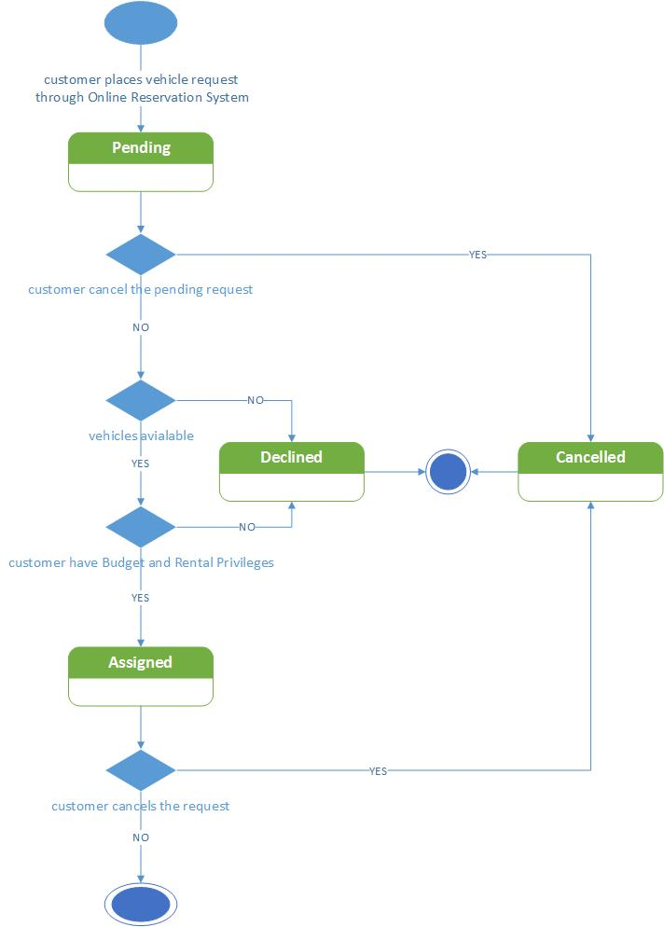**State chart Diagram for Vehicle Request Status**

**Description:** The ‘vehicle request status’ is the status of the vehicle request that has been created by the customer using the online reservation system. The vehicle request consists of the following states:

**Initial State:** Pending,

**Final State:** Assigned, Declined and Cancelled

**Pending:** Once the customer has created the vehicle request in the online reservation system, the status of the vehicle request becomes ‘Pending’ which is the initial state of this request.

**Assigned:** Once the ‘Pending’ vehicle request has been assigned a vehicle by Margie Hall then the status of the vehicle request becomes ‘Assigned’.

**Declined:** The ‘Pending’ vehicle request status will be updated to ‘Declined’ if one of the below conditions are met:

1. Vehicles are not available for the requested date
2. Customer’s rental privileges are revoked
3. Customer’s department does not have enough rental budget

**Cancelled:** The ‘Pending’ vehicle request or ‘Assigned’ vehicle request status will be updated to ‘Declined’ if the customer cancels the vehicle request

**State chart Diagram for Vehicle Status**

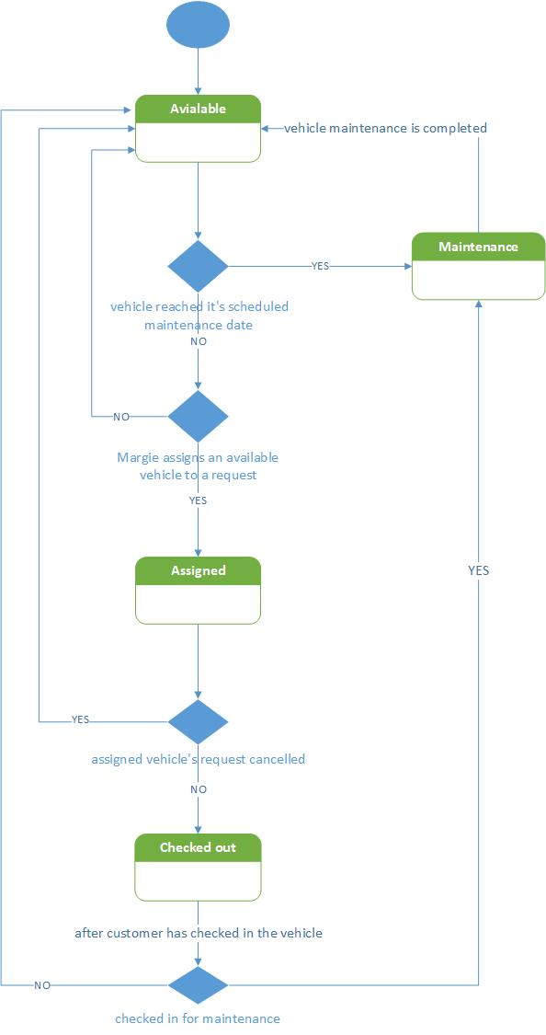

**Description:** The ‘vehicle status’ indicates the different possible states of the vehicles within the corporation fleet. The vehicle status consists of the following states: Available, Assigned, Checked out and Maintenance

**Available:** When the vehicle is present within the corporation fleet garage, the vehicle status is ‘Available’ which is the initial state of the vehicle. The status of the vehicle will should be ‘Available’ if the below scenarios occur:

1. Vehicles having ‘Maintenance’ status have completed their maintenance.
2. Margie Hall does not assign a vehicle to a customer
3. ‘Assigned’ vehicle to the request has been cancelled
4. ‘Checked out’ vehicle has been checked in by the customer

**Assigned:** The ‘Available’ status of the vehicle will be updated to ‘Assigned’ when Margie Hall assigns this vehicle to the customer.

**Maintenance:** The status of the vehicle will be updated to ‘Maintenance’ if either of the scenarios occur:

1. ‘Available’ vehicle has reached it scheduled maintenance date
2. ‘Checked out’ vehicle has been checked in for maintenance

**Checked out:** The ‘Assigned’ status of the vehicle will be updated to ‘Checked out’ when the customer has checked out the vehicle.

**PACKAGE DIAGRAM**

**Description:** Package diagram shows the arrangement and organization of model elements in middle to large scale project. Package diagram can show both structure and dependencies between sub-system or modules.

Package diagram is used:

1. In large scale systems to picture dependencies between major elements in the system
2. Package diagrams represent a compile time grouping mechanism.

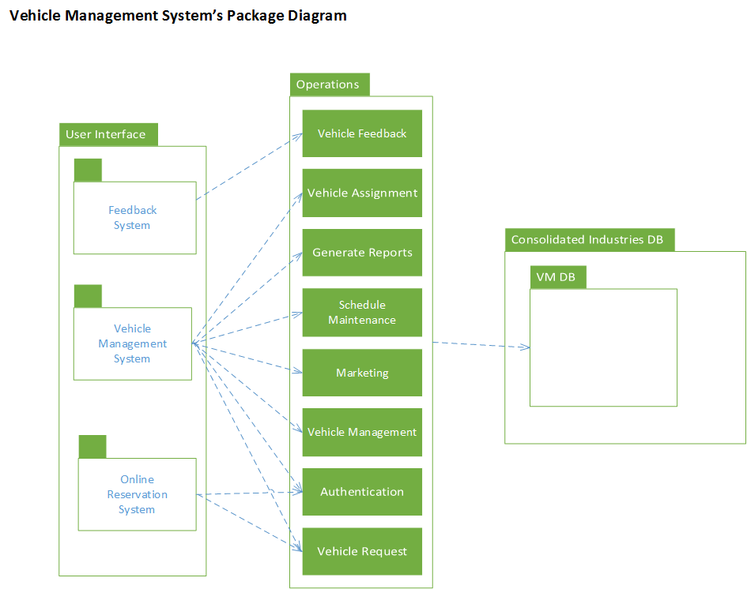

We have modeled our package diagram by considering each package as a module which contains submodules. This package diagram consists of three modules that depicts the structure and the dependencies between the modules of the Vehicle management system. In this diagram, User Interface module depends on Operations module for performing operations like scheduling vehicle maintenance, assigning vehicle, authorizing the user and so on. And this Operation Module in turn depends on the data stored within the VM DB, an element of the Vehicle Management System for managing and retrieving the VM department’s data.

**COMPONENT DIAGRAM**

**Description:** A component diagram depicts how components are wired together to form larger components and or software systems. They are used to illustrate the structure of arbitrarily complex systems.

The below component diagram depicts the involved components and interfaces that make up the vehicle management system.

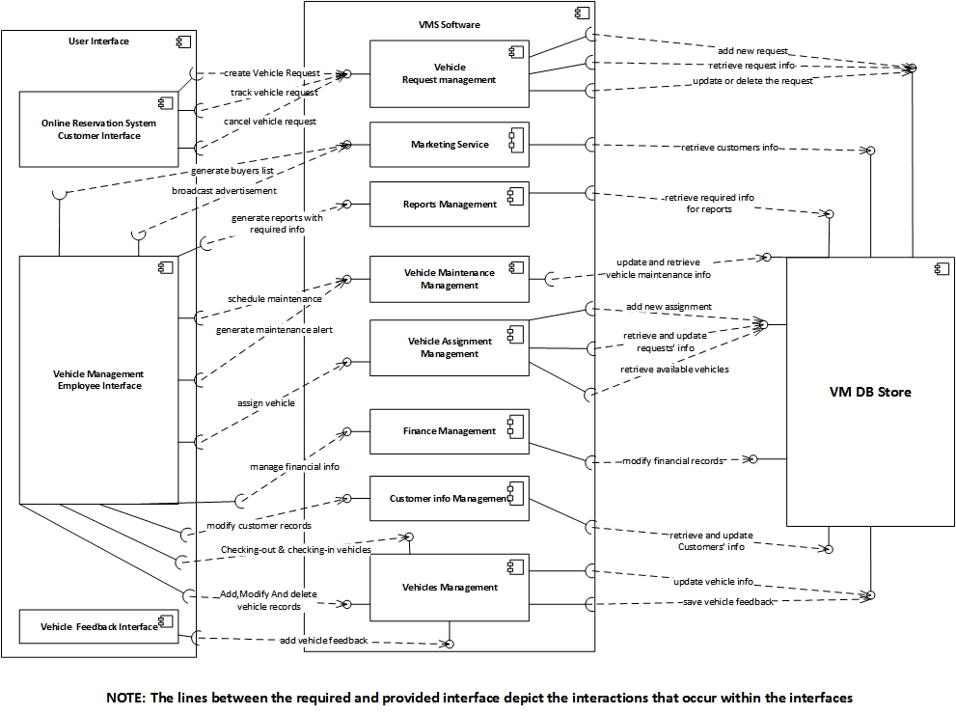

The vehicle management system consists of the following components:

1. **User Interface -** This component provides the interface for the users to interact with the vehicle management software. The user interface component is composed of three sub-components and they are:
   * **Online Reservation System Customer Interface -** This subcomponent is required for providing an interface to the customers for accessing create, track and cancel vehicle request functionalities of the vehicle management system.
   * **Vehicle Management Employee Interface -** This subcomponent is required for providing an interface to the vehicle management employees for performing day to day vehicle management department’s functions like assigning vehicle, generating reports, scheduling maintenance etc.
   * **Vehicle Feedback Interface -** This subcomponent is required for providing an interface to the customer for providing vehicle feedback at the time of vehicle check-in.
2. **VMS Software -** This component performs the vehicle management tasks that have been set by the users via the user interface component (consists of online reservation system interface, VMS interface and feedback interface). The VMS software component is composed of eight sub-components and they are:

* **Vehicle Request Management**
* This subcomponent carries out all the vehicle request operations that includes create, track and cancel vehicle request which are requested by the customers using the online reservation system interface.
* **Marketing Service -** This subcomponent carries out the marketing operations that include generate buyers list and broadcast advertisement which are requested by the VM employees using the vehicle management system interface.
* **Reports Management -** This subcomponent is responsible for generating customizable reports which are requested by the VM employees using the vehicle management system interface.
* **Vehicle Maintenance Management -** This subcomponent carries out the vehicle maintenance related operations that include scheduling the vehicle maintenance and generating maintenance alerts to the customers, which are requested by the VM employees using the vehicle management system interface.
* **Vehicle Assignment Management -** This subcomponent carries out the vehicle assignment operation which is requested by the VM employees using the vehicle management system interface.
* **Finance Management -** This subcomponent manages the vehicle management department’s finance information such as add, delete and modify the financial records which are requested by the VM employees using the vehicle management system interface.
* **Customer Info Management -** This subcomponent is required to handle the operations on customer records such as updating customer’s vehicle usage information and managing the rental privileges of customers which are requested by the VM employees using the vehicle management system interface.
* **Vehicle Management -** This subcomponent carries out the major operations of the vehicle management department that includes check-in/check-out of vehicles, add, delete and modify vehicle records and recording the vehicle feedback.

1. **VM DB Store -** This component holds the vehicle management department’s data that can only be accessed and managed by the VMS Software component of the vehicle management system. The data in this component is required for performing the daily operations of the vehicle management department.

**DEPLOYMENT DIAGRAM**

**Description:** A deployment diagram in the [Unified Modeling Language](https://en.wikipedia.org/wiki/Unified_Modeling_Language) models the physical deployment of [artifacts](https://en.wikipedia.org/wiki/Artifact_(UML)) on [nodes](https://en.wikipedia.org/wiki/Node_(UML)). The below deployment diagram depicts the various involved nodes, artifacts and its communications within the vehicle management system.

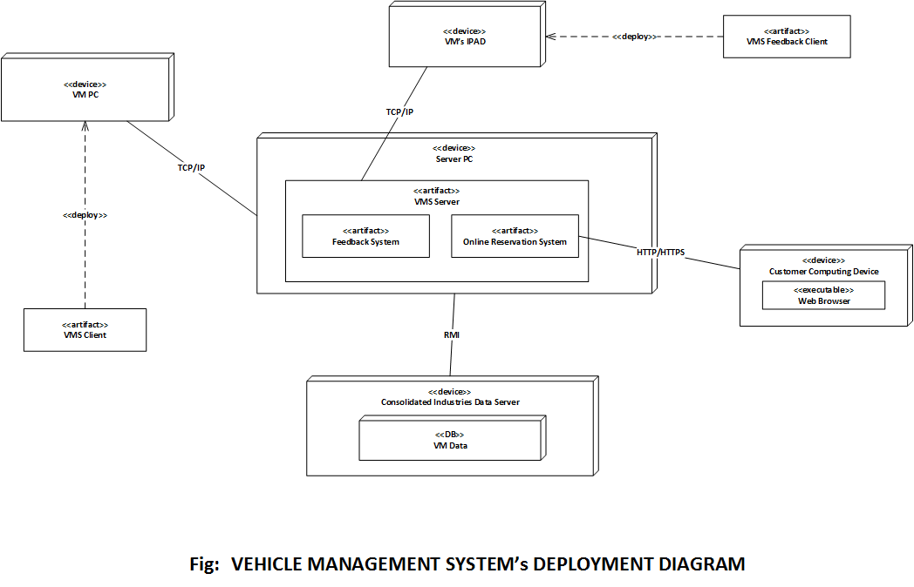

The vehicle management system consists of the following nodes:

1. **VMS User PC**

The VMS User PC is provided to all the employees of the vehicle management department which is connected to the VMS Server using the TCP/IP. This pc will contain the VMS Client software which will perform the vehicle management functions.

1. **VMS Printer**

The VMS Printer is provided to all the employees of the vehicle management department which is connected to the VMS Server using the TCP/IP. The printer will be used for printing bills,receipts,reports etc.

1. **VM Database**

The VM Server is connected to the VM Database via the Remote Method Invocation (RMI). The VM Database is incorporated within the Consolidated Industries Data Server, where the VM Database contains the vehicle management department’s data.

1. **VMS User IPAD**

The VMS User IPAD is provided to the vehicle reservations clerical staff in the vehicle management department which is connected to the feedback system artifact within the VMS Server using the HTTP/HTTPS. This iPad will contain the VMS Feedback Client software which will perform the vehicle feedback functions.

1. **Customer PC**

The Customer PC are the personal computers of the customers that are using the online reservation system to manage the vehicle request. The customers can access the online reservation system using the web browser, which is connected to the Online Reservation System artifact within the VM Server via the HTTP/HTTPS.

1. **VMS Server**

The VMS Server is a pc that manages all the communications between the various components involved within the vehicle management system. The server contains two artifacts namely, Online Reservation System and Feedback System which are required to handle the customer vehicle request service and vehicle feedback service.

1. **CONCLUSION**

* VMS will decrease the vehicle management department’s workload by making reservation process, management of vehicle easier
* VMS will collect the feedback from the customers which allows to fix the vehicle problems
* VMS will also help the users in determining the car condition which helps them to better analyze the resale value
* Receipts, bills and customized reports will be easy to generate using the VMS